MULTI-DISEASE PREDICTION USING MACHINE LEARNING
(An Intelligent Health Assistant for Diabetes, Heart, Liver and Kidney Risk)
Block Diagrams (all)
Department of Computer Science and Engineering, TKR College of Engineering and Technology (Autonomous)
Batch A3 (CSE-A) · Academic year [ACADEMIC YEAR]
Table 1: Project team
S.No. | Student name | Roll number
1 | AJMEERA HARINI | 23K91A0507
2 | BANDI LIKITHA | 23K91A0526
3 | CHINTHAKINDI SWATHI | 23K91A0555
4 | BADROJU SRI HANSIKA | 23K91A0524

Project guide: B. SRUTHI, Faculty Project Guide, Department of CSE
Chapter and section numbers quoted in the text (for example Section 6.6 or Chapter 8) refer to the full project report, 17.Final Document. Figures and tables in this document are numbered from 1.

1. INDEX OF DIAGRAMS
Every diagram is generated from the real design by scripts/make_diagrams.py (matplotlib, 150 dpi) and mirrors the code in train_models.py, app.py, backend/ and frontend/. There is no SQL database, so the entity-relationship diagram shows the logical data model.
Table 2: Diagrams in this document
No. | Diagram | Image file
1 | System architecture | docs/diagrams/01_system_architecture.png
2 | High-level workflow | docs/diagrams/02_high_level_workflow.png
3 | Data flow diagram, level 0 | docs/diagrams/03_dfd_level0.png
4 | Data flow diagram, level 1 | docs/diagrams/04_dfd_level1.png
5 | Data flow diagram, level 2 | docs/diagrams/05_dfd_level2.png
6 | UML class diagram | docs/diagrams/06_uml_class_diagram.png
7 | Sequence diagram | docs/diagrams/07_sequence_diagram.png
8 | Use-case diagram | docs/diagrams/08_use_case_diagram.png
9 | Entity-relationship diagram | docs/diagrams/09_er_diagram.png
10 | Core algorithm flowchart | docs/diagrams/10_core_algorithm_flowchart.png

2. DIAGRAMS

System architecture
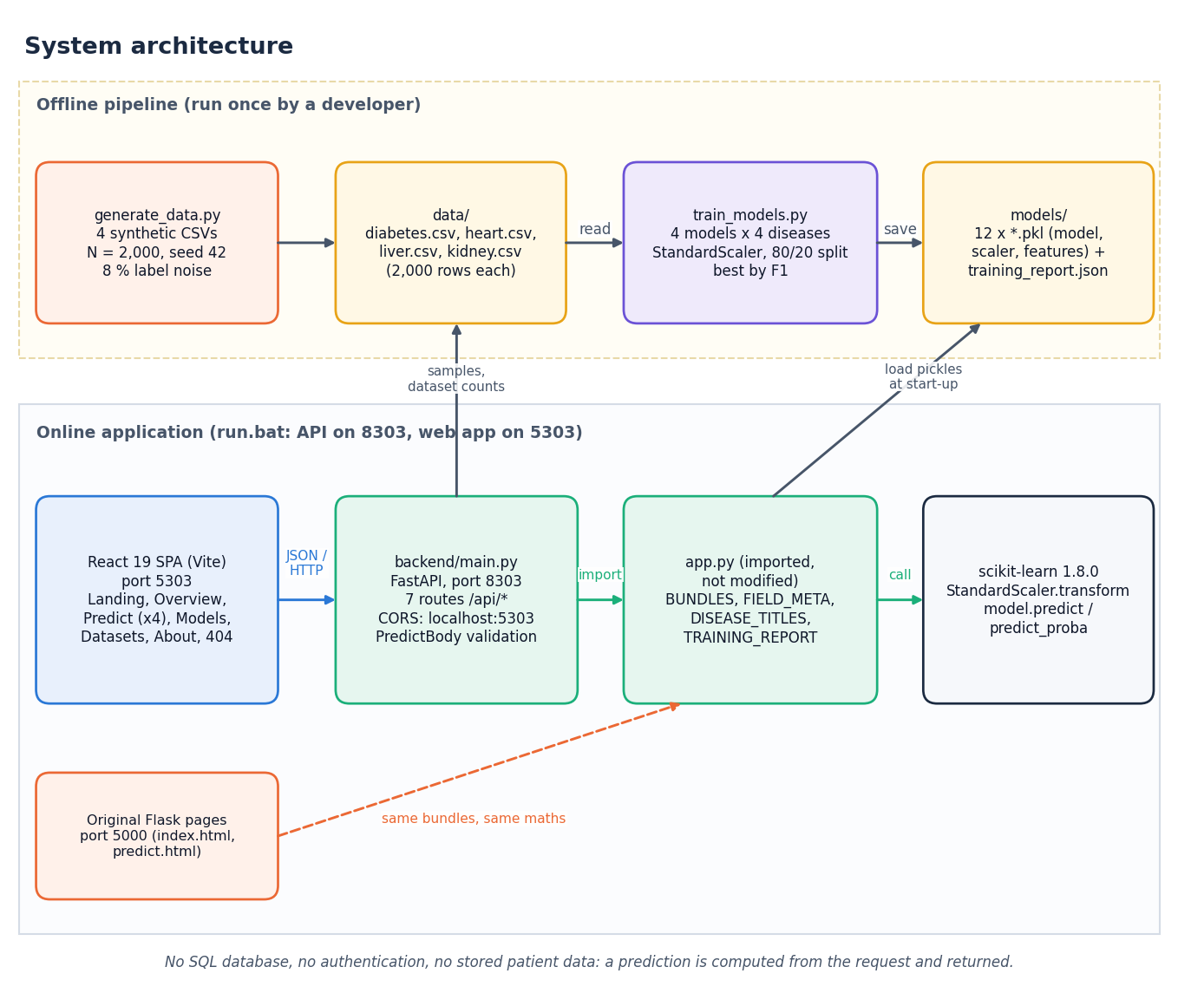
Figure 1: System architecture of the Intelligent Health Assistant
The figure separates an offline pipeline from the online application. Offline, generate_data.py writes the four CSV files in data/, and train_models.py reads them and writes twelve pickle files (model, scaler and feature list for each disease) and training_report.json into models/. Online, run.bat starts the FastAPI service on port 8303 and the React application on port 5303; the React application calls the API with JSON over HTTP, the API imports app.py (which loads the pickles at start-up and holds the field metadata), and app.py calls scikit-learn for scaling and prediction. The API also reads the CSV files for the sample rows and dataset counts. The original Flask pages on port 5000 use the same bundles and the same arithmetic. The footnote states the main design fact: there is no SQL database, no authentication and no stored patient data.

High-level workflow
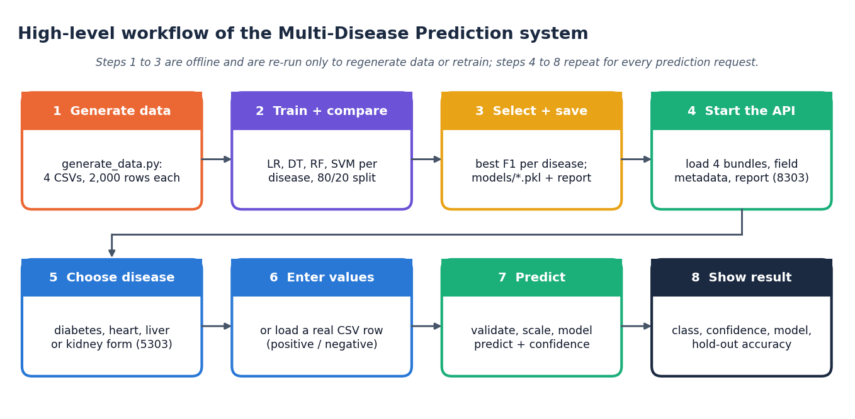
Figure 2: High-level workflow of the system
Eight steps in two rows. Steps 1 to 3 (generate data, train and compare, select and save) are offline and are repeated only to regenerate the data or retrain. Steps 4 to 8 happen at run time: the API loads the bundles, the user chooses a disease, enters values or loads a real sample row, the API validates, scales and predicts, and the interface shows the class, the confidence, the model and its hold-out accuracy.

Data flow diagram, level 0
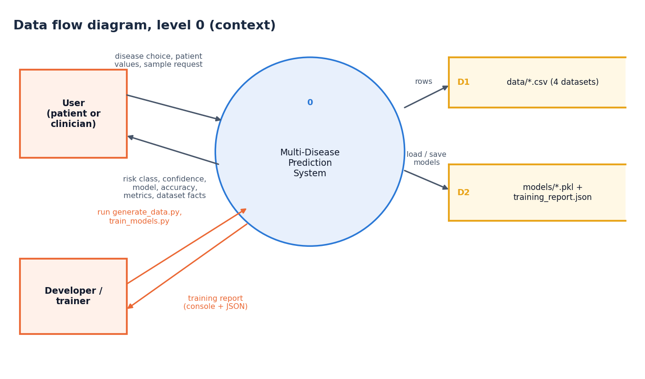
Figure 3: Data flow diagram, level 0 (context)
One process, the Multi-Disease Prediction System, exchanges data with two external entities. The user sends a disease choice, patient values or a sample request and receives a risk class, a confidence, the model and its accuracy, and metrics and dataset facts. The developer runs the data generator and the training script and receives the training report. Two data stores are used: D1, the four CSV files, and D2, the pickle files and the training report.

Data flow diagram, level 1
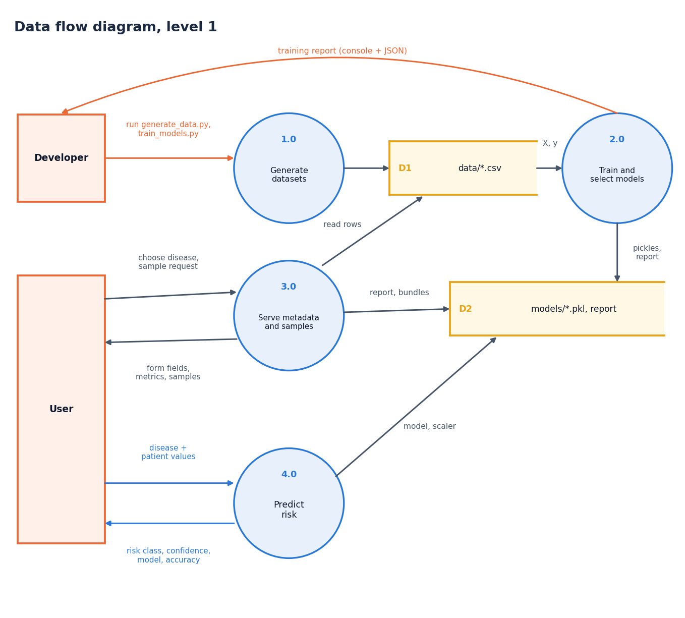
Figure 4: Data flow diagram, level 1
The system is decomposed into four processes. Process 1.0 generates the datasets and writes them to D1. Process 2.0 reads D1, trains and selects the models and writes the bundles and report to D2. Process 3.0 serves form metadata, metrics and sample rows to the user from D1 and D2. Process 4.0 receives a disease and patient values from the user, reads the bundle from D2 and returns the risk class, confidence, model and accuracy.

Data flow diagram, level 2
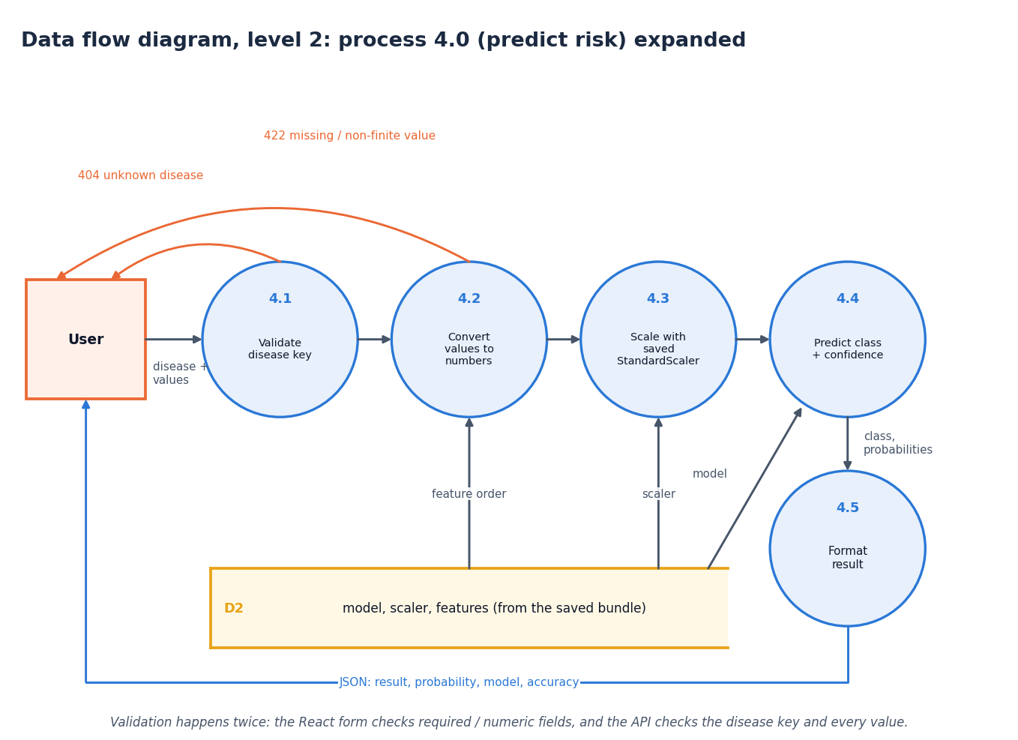
Figure 5: Data flow diagram, level 2: process 4.0 (predict risk) expanded
Process 4.0 expands into five sub-processes: 4.1 validates the disease key (an unknown key returns 404 to the user), 4.2 converts every value to a finite number in the saved feature order (a missing or non-finite value returns 422), 4.3 scales the vector with the saved StandardScaler, 4.4 predicts the class and the class probabilities with the saved model, and 4.5 formats the JSON result. Processes 4.2 to 4.4 read the feature order, the scaler and the model from the D2 bundle. The footnote records that validation happens twice: in the React form and again in the API.

UML class diagram
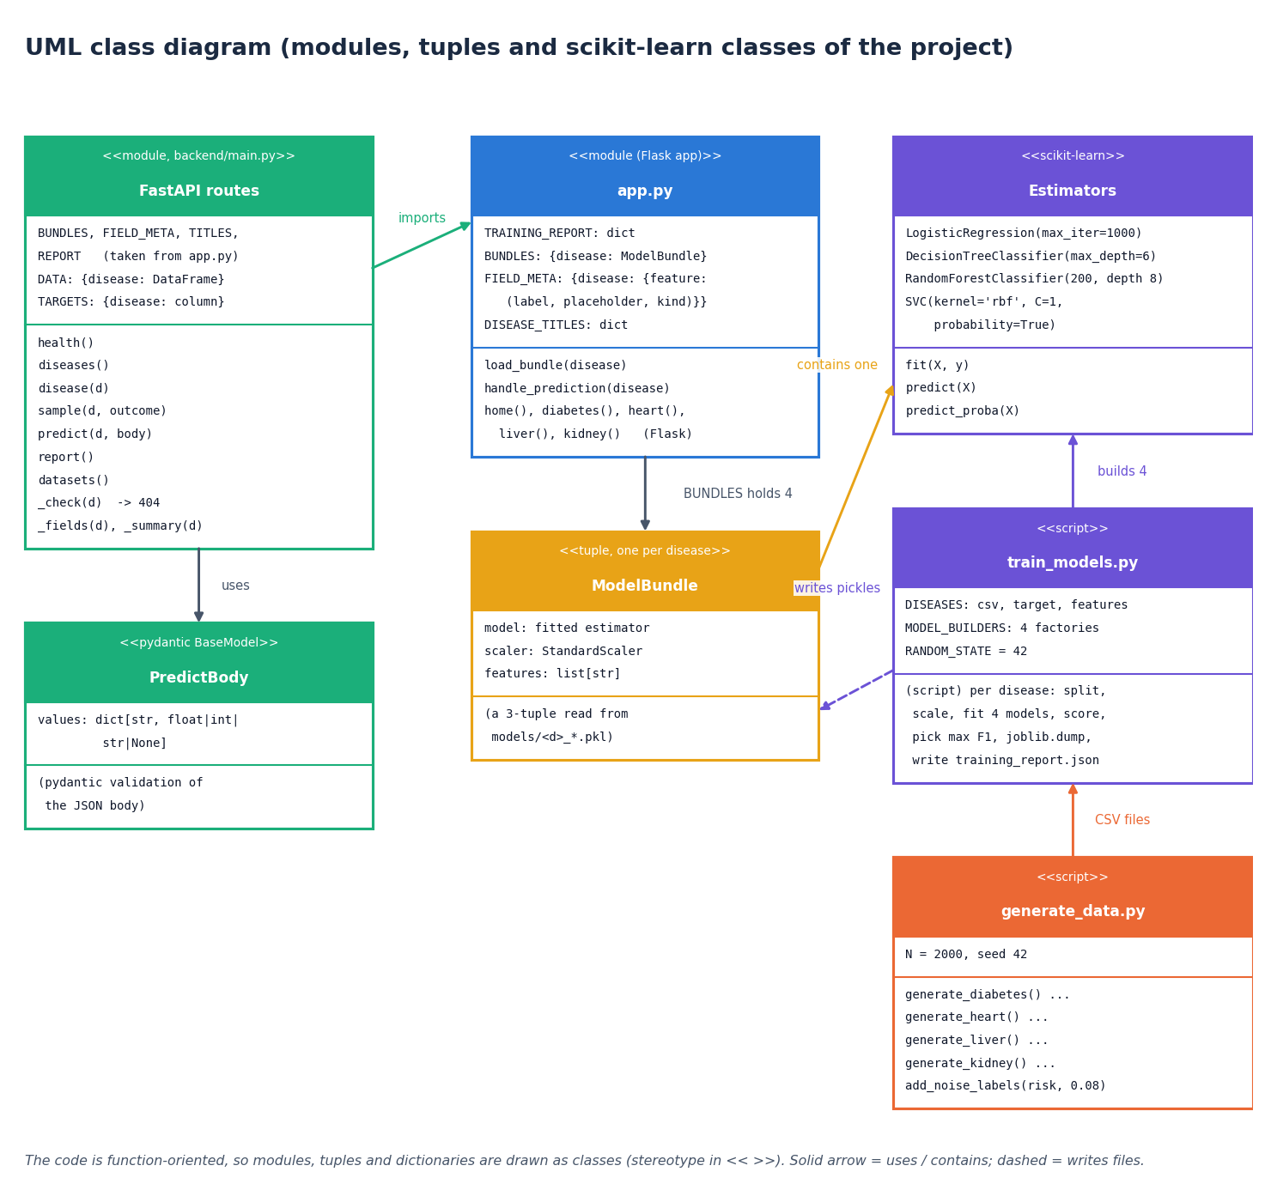
Figure 6: UML class diagram (modules, tuples and scikit-learn classes of the project)
The code base is function-oriented, so most boxes are modules or plain data structures drawn with a stereotype: the FastAPI routes of backend/main.py (with the PredictBody pydantic model), the Flask module app.py that holds TRAINING_REPORT, BUNDLES, FIELD_META and DISEASE_TITLES, the ModelBundle tuple (model, scaler, features), the training script, the data generator, and the four scikit-learn estimator classes with their constructor settings. Solid arrows mean uses or contains; dashed arrows mean writes files. The only real classes are the pydantic PredictBody and the scikit-learn estimators; no class was invented for the diagram.

Sequence diagram
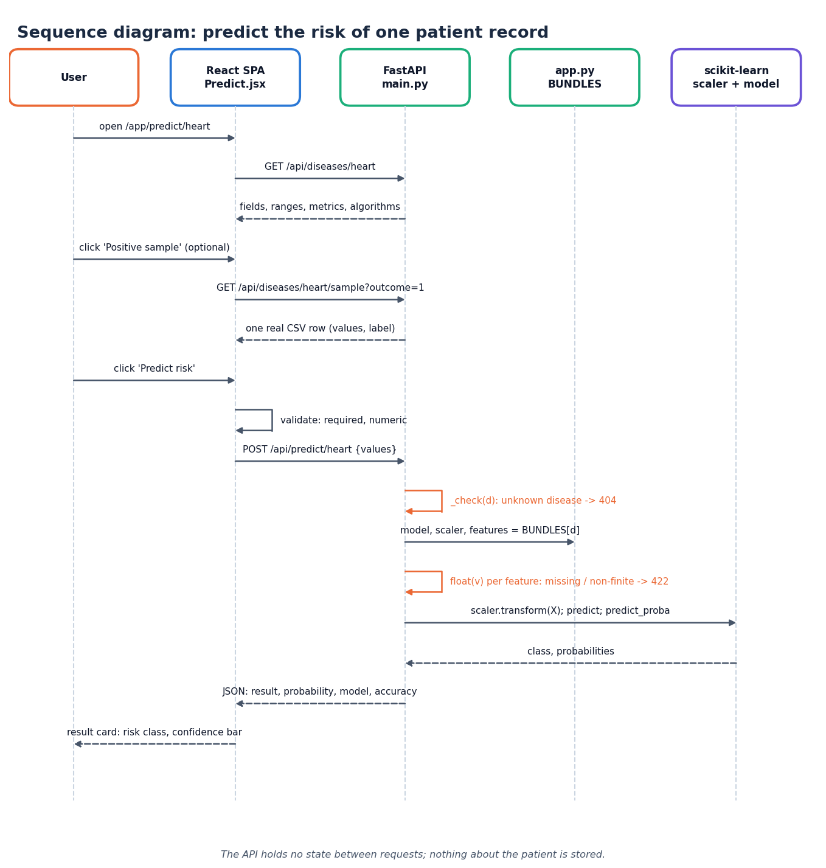
Figure 7: Sequence diagram: predict the risk of one patient record
The messages exchanged when a user opens the heart-disease page, loads a positive sample row and presses Predict risk. The React page fetches the field metadata, then the sample row, validates the form locally, and posts the values; the API checks the disease key, takes the bundle from app.py, converts the values, scales them, calls the model and returns the JSON result that the page shows as a result card. The footnote records that the API keeps no state between requests.

Use-case diagram
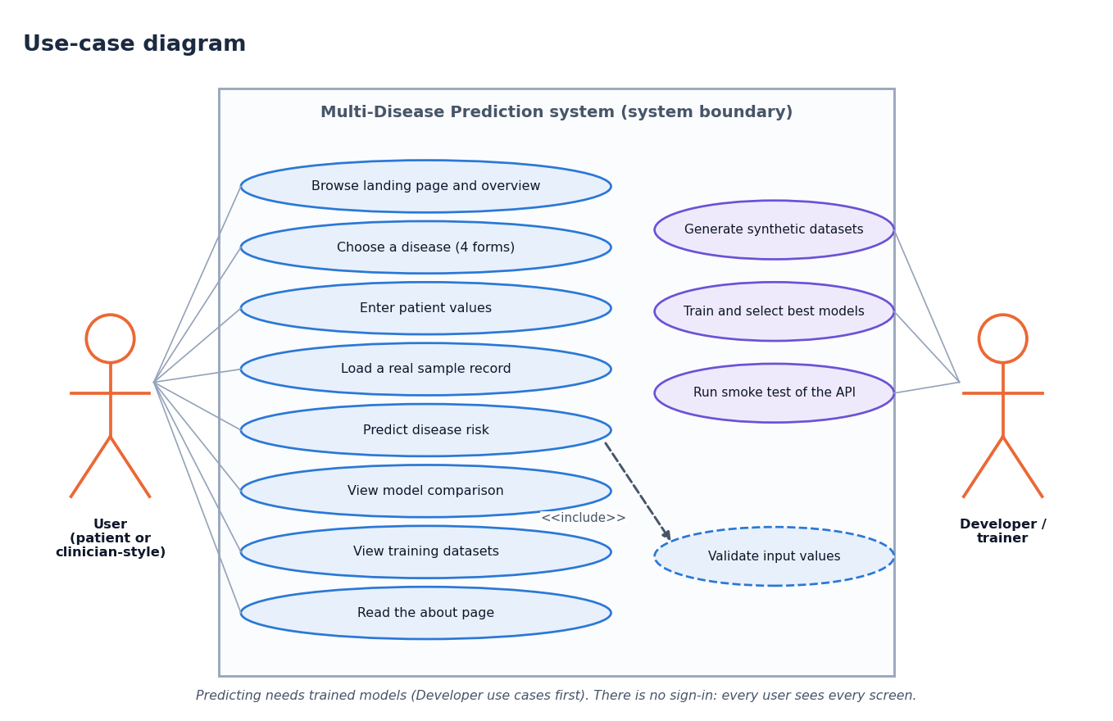
Figure 8: Use-case diagram
Two actors and eleven use cases. The user can browse the landing page and overview, choose a disease, enter patient values, load a real sample record, predict disease risk (which includes validation of the input), view the model comparison, view the training datasets and read the about page. The developer can generate the synthetic datasets, train and select the best models and run the smoke test of the API. There is no sign-in: every user sees every screen, and predicting needs the models that the developer use cases create.

Entity-relationship diagram
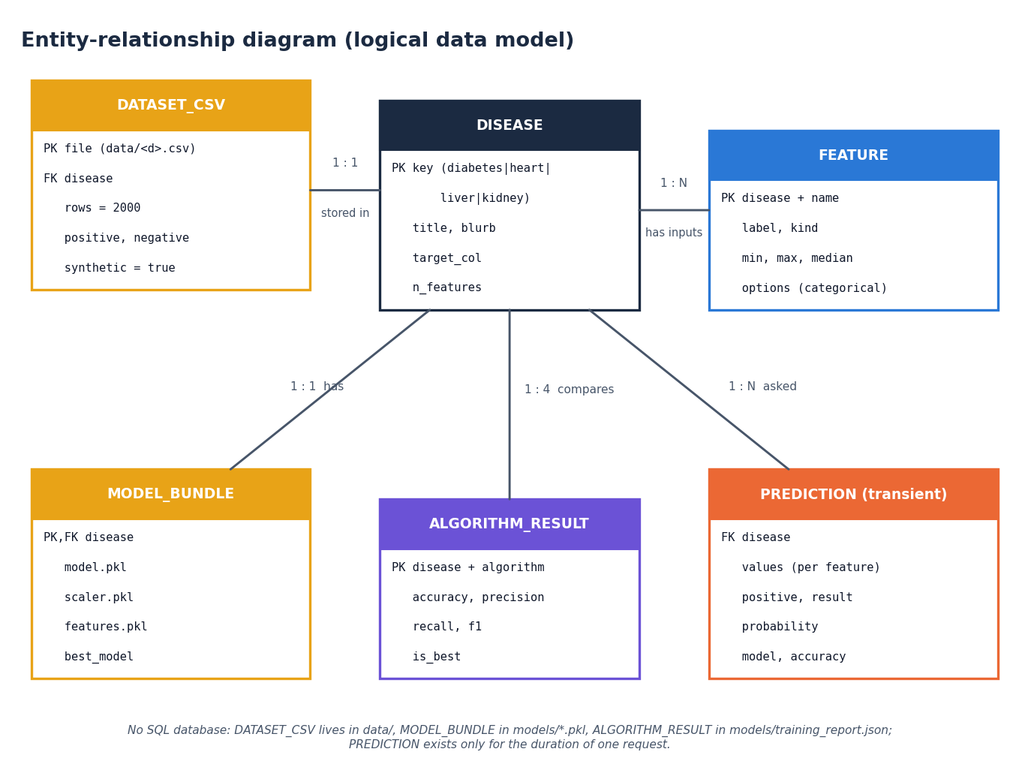
Figure 9: Entity-relationship diagram (logical data model)
The project has no database, so this is the logical data model of the artefacts the code handles. A DISEASE has one DATASET_CSV, many FEATUREs (the form inputs), one MODEL_BUNDLE (model, scaler and feature-list pickles plus the name of the best model), four ALGORITHM_RESULTs (the metrics of the four algorithms in training_report.json) and many PREDICTIONs; a PREDICTION is transient and exists only for the duration of one request.

Core algorithm flowchart
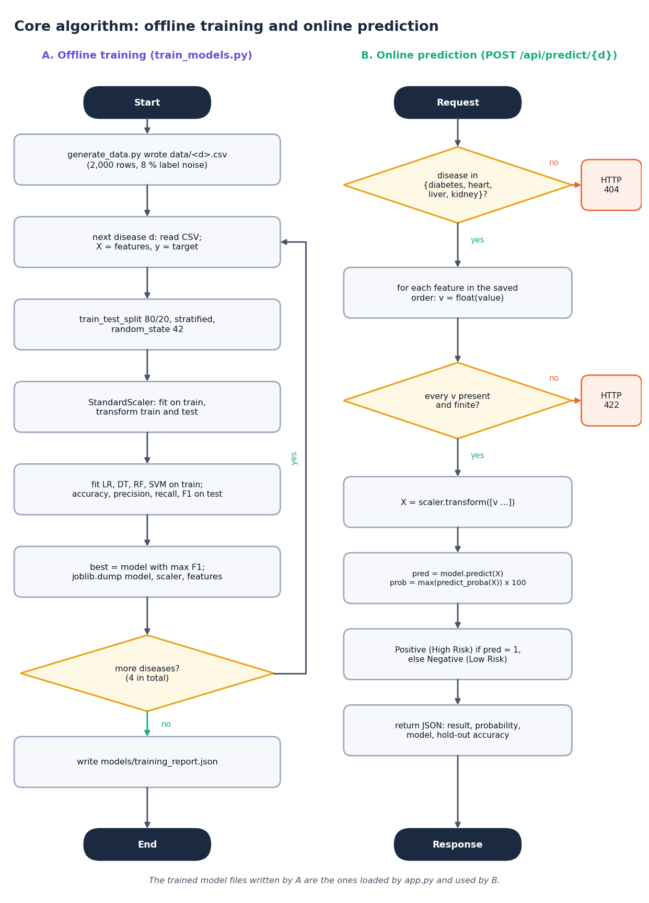
Figure 10: Flowchart of the core algorithm: offline training and online prediction
Panel A is the offline training loop of train_models.py: read the CSV of a disease, split 80/20 with stratification and seed 42, fit the StandardScaler on the training part, fit and score the four algorithms, keep the one with the highest F1, dump model, scaler and features, repeat for the next disease, and finally write the training report. Panel B is the online prediction of POST /api/predict/{d}: check the disease key (404), convert every feature to a float and check that it is finite (422), scale, predict, derive the class and the confidence, and return the JSON.

